Collection30Functions Source Code Instructions v1.0
October 10, 2021
by Vagelis Plevris and German Solorzano
Article:
A Collection of 30 Unconstrained Multidimensional Benchmark Functions for Global Single-Objective Optimization
The version of MATLAB used is R2020b.

File: “Collection30Functions Instructions.docx”
This Word file with the instructions.
Folder: “mainprog\functions” and files in this folder
Instructions: The folder contains the following 30 functions (shown here in alphabetical order based on file name):
No | Function | File name
1 | F08 Ackley’s function | ackley_func.m
2 | F07 Alpine 1 function | alpine1_func.m
3 | F16 Bent Cigar function | bent_cigar_func.m
4 | F15 Discus function | discus_func.m
5 | F05 Drop-Wave function | drop_wave_func.m
6 | F02 Ellipsoid function | ellipsoid_func.m
7 | F14 High Conditioned Elliptic | ellipt_func.m
8 | F19 Expanded Schaffer’s F6 function | expschafferf6_func.m
9 | F09 Griewank’s function | griewank_func.m
10 | F11 HappyCat function | happycat_func.m
11 | F12 HGBat function | hgbat_func.m
12 | F27 Modified Ridge | modridge_func.m
13 | F29 Modified Xin-She Yang’s 3 | modxinsyang3_func.m
14 | F30 Modified Xin-She Yang’s 5 | modxinsyang5_func.m
15 | F17 Perm D, Beta function | permdb_func.m
16 | F04 Quintic function | quintic_func.m
17 | F10 Rastrigin’s function | rastrigin_func.m
18 | F13 Rosenbrock’s function | rosenbrock_func.m
19 | F20 Rotated Hyper-ellipsoid function | rothellipsoid_func.m
20 | F26 Salomon function | salomon_func.m
21 | F18 Schaffer’s F7 function | schafferf7_func.m
22 | F21 Schwefel function | schwefel_func.m
23 | F24 Schwefel 2.21 function | schwefel221_func.m
24 | F25 Schwefel 2.22 function | schwefel222_func.m
25 | F01 Sphere function | sphere_func.m
26 | F03 Sum of Different Powers function | sumpow_func.m
27 | F22 Sum of Different Powers 2 function | sumpow2_func.m
28 | F06 Weierstrass function | weierstrass_func.m
29 | F23 Xin-She Yang’s 1 function | xinsheyang1_func.m
30 | F28 Zakharov function | zakharov_func.m

These functions are called from other programs, when the calculation of the value of an objective function is needed. The functions are used in the code and the results of the paper.

File: “mainprog\functions.txt”
The file contains the following:
function_name(no_spaces) file Lower_bound Upper_Bound
Sphere sphere_func -100 100
Ellipsoid ellipsoid_func -100 100
SumOfDifferentPowers sumpow_func -10 10
Quintic quintic_func -20 20
Drop-Wave drop_wave_func -5.12 5.12
Weierstrass weierstrass_func -0.5 0.5
Alpine1 alpine1_func -10 10
Ackley’s ackley_func -32.768 32.768
Griewank’s griewank_func -100 100
Rastrigin’s rastrigin_func -5.12 5.12
HappyCat happycat_func -20 20
HGBat hgbat_func -15 15
Rosenbrock's rosenbrock_func -10 10
HighConditionedEllipticfunction ellipt_func -100 100
Discus discus_func -100 100
BentCigar bent_cigar_func -100 100
PermFunctionDBeta permdb_func -50 50
Schaffer’sF7 schafferf7_func -100 100
ExpandedSchaffer’sF6 expschafferf6_func -100 100
RotatedHyper-ellipsoid rothellipsoid_func -100 100
Schwefel schwefel_func -500 500
SumOfDifferentPowers2 sumpow2_func -10 10
Xin-SheYang’s1 xinsheyang1_func -6.283185307 6.283185307
Schwefel2.21 schwefel221_func -100 100
Schwefel2.22 schwefel222_func -100 100
Salomon salomon_func -20 20
ModifiedRidge modridge_func -100 100
Zakharov zakharov_func -10 10
ModifiedXin-SheYang’s3 modxinsyang3_func -20 20
ModifiedXin-SheYang’s5 modxinsyang5_func -100 100

It is a list of the 30 functions with their name, the file name and the lower and upper bounds for each function. This file is read in the beginning of other programs.

File: “test_functions_time.m”
Instructions: Simply run the file with MATLAB and you will get the figure with the results.
Prerequisites:
- The file needs the folder “functions” (containing the 30 functions) to be in the “mainprog” directory.
- The file needs the text file “functions.txt” to be in the “mainprog” directory
- The file also saves a figure in .fig, .emf and .png formats. For this, the following folder structure (can be empty) needs to exist: \Figures\FunctionsTime\ in the root directory.
It calculates the values of the 30 objective functions NumRuns times for D = 5, 10, 30 and 50, records the time needed (in sec) and plots the results in a figure (y-axis is in logarithmic scale).
In the paper, we use NumRuns=100,000 but in the code provided we have set this number to 1000 for faster results. You can adjust this using the line
NumRuns=1e3; %Times to calculate each function

Note that different runs of the test_functions_time.m program will give slightly different results each time, while the results depend also on the hardware (computer) used. The results presented in the paper were taken running the program on a computer with Windows 10, equipped with an Intel i9-8950HK CPU @ 2.90GHz and 32 GB RAM.
When the program is run, it generates the following files:
- elapsedTime.mat, contains the Times needed for every run as a 4x30 matrix, where 30 is the number of functions and 4 is the different dimensions used (D=5, 10, 30 and 50).
- \Figures\FunctionsTime\AllTimes.fig, the figure with the times, in .fig format
- \Figures\FunctionsTime\AllTimes.emf, the figure with the times, in .emf format
- \Figures\FunctionsTime\AllTimes.png, the figure with the times, in .png format
The figure in the paper is the following (for NumRuns=100,000):
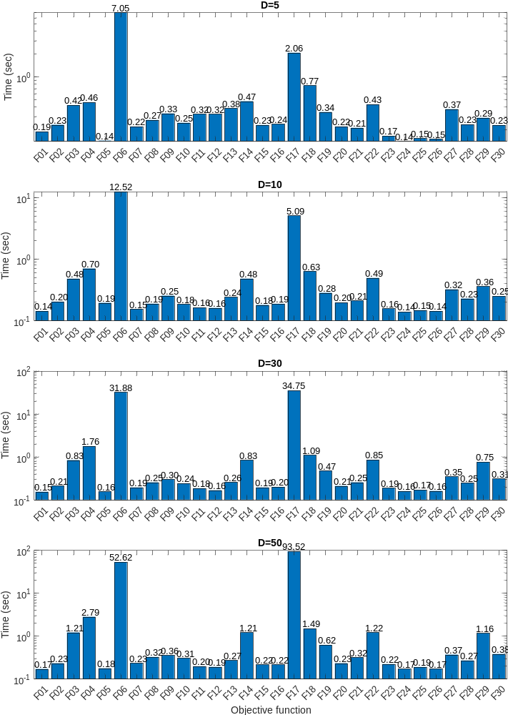

File: “plot_all_functions_2D.m”
Instructions: Run the file with MATLAB and you will get the figures with the plots of all 30 functions in 2D. The function file names and the bounds for each function are read from the file “mainprog\functions.txt”
Prerequisites:
- The file needs the folder “functions” (containing the 30 functions) to be in the “mainprog” directory.
- The file needs the text file “functions.txt” to be in the “mainprog” directory
- The file also saves the figures in .fig, .emf and .png formats. For this, the following folder structure (can be empty) needs to exist:
  - \Figures\FunctionsIn2D\ in the root directory.
The program plots all the functions from -Bound to Bound in both directions (x₁, x₂) as a surface. When the program is run, it generates the following files:
- \Figures\FunctionsIn2D\FXX - YYY.fig, the figure of the XX-th function, named “YYY”, in .fig format. 30 .fig figures in total are generated.
- \Figures\FunctionsIn2D\FXX - YYY.emf, the figure of the XX-th function, named “YYY”, in .emf format. 30 .emf figures in total are generated.
- \Figures\FunctionsIn2D\FXX - YYY.png, the figure of the XX-th function, named “YYY”, in .png format. 30 .png figures in total are generated.
The 1st figure that is produced is the following (F01 - Sphere Function):

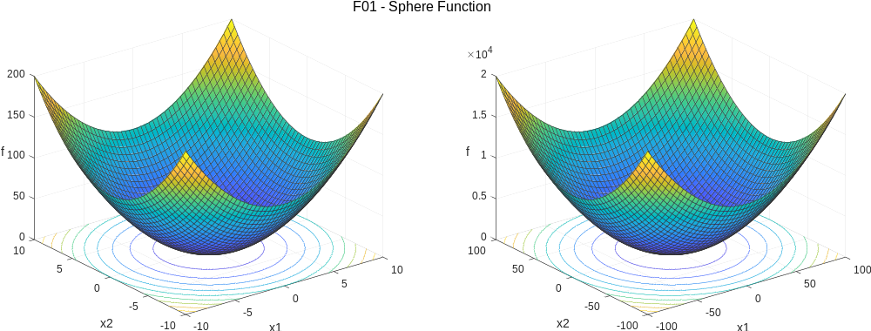

File: “schwefel_investigation.m”
Instructions: Run the file with MATLAB and you will get the figure with the investigation of the Schwefel function (F21) in one-dimension, which is included in Appendix A of the paper.
Prerequisites:
- The file saves the figures in .fig, .emf and .png formats. For this, the following folder structure (can be empty) needs to exist:
  - \Figures\Schwefel\ in the root directory.
The program plots the function 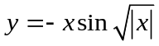 from -500 to 500, as shown below.
When the program is run, it generates the following files:
- \Figures\Schwefel\Investigation of the Schwefel function (F21).fig.
- \Figures\Schwefel\Investigation of the Schwefel function (F21).emf.
- \Figures\Schwefel\Investigation of the Schwefel function (F21).png.
The figure that is produced is the following:
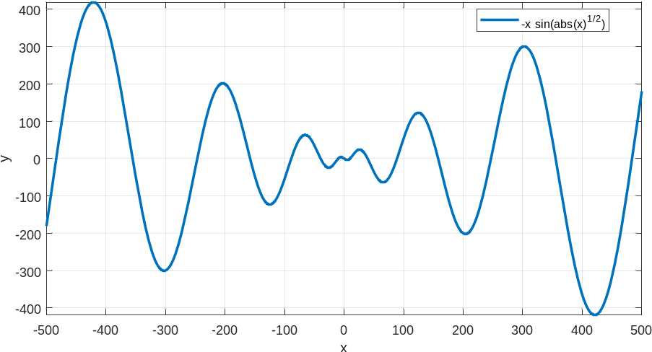

File: “mainprog\gaoutputfcn.m”
Instructions: No need to run this program. This program is called from the main.m file. It is the gaoutputfcn GA function of MATLAB with some modifications needed to record the results of GA.

File: “mainprog\pswplotranges.m”
Instructions: No need to run this program. This program is called from the main.m file. It is the pswplotranges PSO function of MATLAB with some modifications needed to record the results of PSO.

File: “mainprog\outfunSQP.m”
Instructions: No need to run this program. This program is called from the main.m file. It is the outfun SQP function of MATLAB with some modifications needed to record the results of SQP.

File: “main.m”
Instructions: This is the main file of the study. Run the file with MATLAB and you will get the full optimization results, for all 30 functions and 4 dimensions (5, 10, 30, 50).
Prerequisites:
- The folder “functions” (containing the 30 functions) is needed to be in the “mainprog” directory.
- The text file “functions.txt” is needed to be in the “mainprog” directory.
- The files “gaoutputfcn.m”, “pswplotranges.m” and “outfunSQP.m” are needed to be in the “mainprog” directory.
- The file also saves the convergence history figures in .fig, .emf and .png formats. For this, the following folder structure (can be empty) needs to exist: \Figures\OptiResults\ in the root directory.
It runs all the optimization problems with the 30 functions and with D=5, 10, 30 and 50 and plots the convergence history results (y-axis is in logarithmic scale).
In the paper, we use NumRuns=10 but in the code provided we have set this number to 1 for faster results. You can adjust this using the line
NumRuns=1; % Each problem is run 10 times in the paper
When the program is run, it generates the following figure files in .fig, .emf and .png formats:
- \Figures\OptiResults\Number of dimensions D=5, Functions F01-F15.fig (also .emf, .png)
- \Figures\OptiResults\Number of dimensions D=5, Functions F16-F30.fig (also .emf, .png)
- \Figures\OptiResults\Number of dimensions D=10, Functions F01-F15.fig (also .emf, .png)
- \Figures\OptiResults\Number of dimensions D=10, Functions F16-F30.fig (also .emf, .png)
- \Figures\OptiResults\Number of dimensions D=30, Functions F01-F15.fig (also .emf, .png)
- \Figures\OptiResults\Number of dimensions D=30, Functions F16-F30.fig (also .emf, .png)
- \Figures\OptiResults\Number of dimensions D=50, Functions F01-F15.fig (also .emf, .png)
- \Figures\OptiResults\Number of dimensions D=50, Functions F16-F30.fig (also .emf, .png)

It also generates the following files:
- AllProblems.mat, contains the optimization results, for all problems and all runs. It is a 1x4 cell structure.
- AllTimes.mat, contains the time needed for the execution of each problem, for all problems and all runs. It is a 1x4 cell structure.

File: postprocessing.m
Instructions: This file reads the optimization results (after the main program has run) and plots some additional figures with (a) the final optimum value of each function, for all 30 functions and 4 dimensions (5, 10, 30, 50), (b) the time needed for each optimizer to solve each problem.
Prerequisites:
- The files “AllProblems.mat” and “AllTimes.mat” are needed to be in the root directory. These files are generated from the main program when the optimization is run.
- The file saves the final optimum values figures in .fig, .emf and .png formats. For this, the following folder structure (can be empty) needs to exist: \Figures\OptiFunctionValues\ in the root directory.
- The file saves the figure with the times needed, in .fig, .emf and .png formats. For this, the following folder structure (can be empty) needs to exist: \Figures\OptiTimes\ in the root directory.

It reads the optimization results and plots the final function values for the 30 functions and all optimization methods, for D=5, 10, 30 and 50. It also plots the time needed for each method and each problem. Note that in the plots the y-axis is in logarithmic scale. This is true for both the objective function values (where the max value for y has been set to 100,000) and the time needed for each problem (where the max value for y is automatic and set by Matlab).
Note that in the paper, we have used NumRuns=10 in the main program but in the code provided here we have set this number to 1 for faster results.
When the program is run, it generates the following figure files in .fig, .emf and .png formats:
- \Figures\OptiFunctionValues\FunctionValues5_10.fig (also .emf, .png)
- \Figures\OptiFunctionValues\FunctionValues30_50.fig (also .emf, .png)
- \Figures\OptiTimes\OptiTimes.fig (also .emf, .png)

